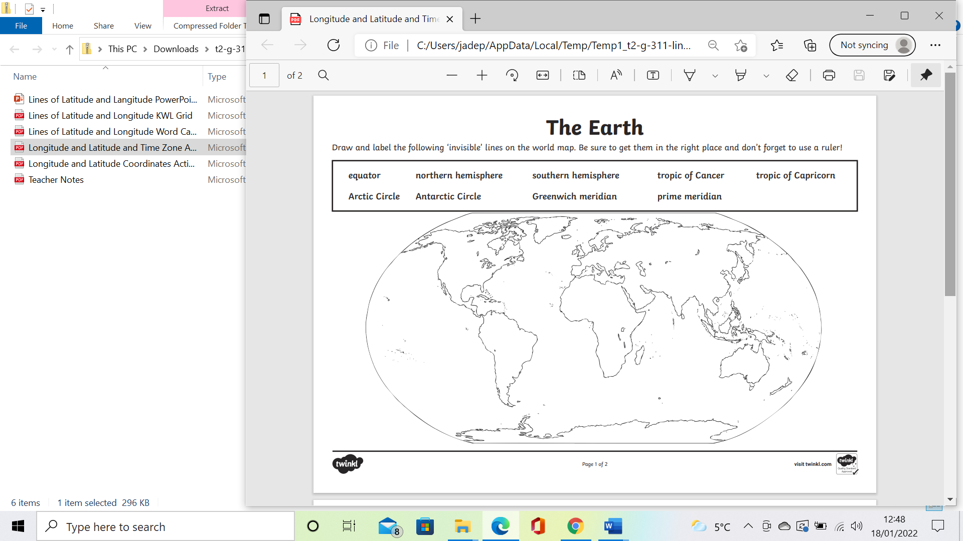

Equator Northern Hemisphere Southern Hemisphere Arctic Circle Antarctic Circle